

RICHARD III SOCIETY CONVENTION
25-26 September 2026
(Booking deadline 1 September 2026)
Social Evening & Convention Fact File and Programme
Booking Forms
Please email booking form to events@richardiii.net
or post to:
18 Berberis Close, Walnut Tree, Milton Keynes MK7 7DZ

Friday 25 September
Social Evening and Quiz at The Cosy Club,
16-18 Victoria Street, Nottingham NG1 2EX

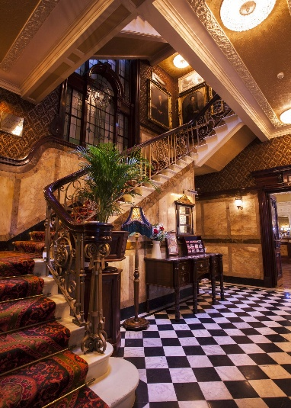
The entrance hall and stairway
NB: No lift is available

The event will take place in the Imperial Room and the evening will include a two-course buffet supper of hot main plus dessert and a quiz. The programme will be: 19:00 Drinks and Social ֎ 19:30 Supper ֎ 20:15 Quiz
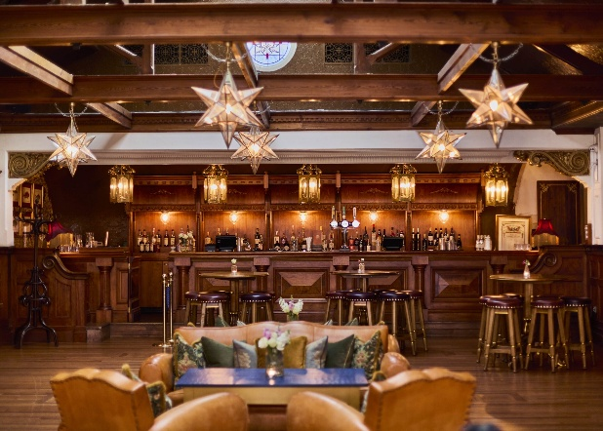
The Imperial Room on the 2nd Floor

We will be treated to a sharing feast with no need to select your dishes in advance. A typlical selection of menu options:
Mains
Asian fried chicken (GF) Ceasar salad (V)
Flat iron steak (GF) Roasted squash & red onion tangine (VG)
Crispy fried halloumi (V) Middle eastern tabbeouleh salad (VG)
Whipped feta & hot honey (V) Traditional laffa flatbread (V)
Panko butterflied king prawns Skin-on fries (VG, GF)
Vietnamese fried cauliflower (VG, GF) Warm monkey bread (V)
Dessert
Dark chocolate Mousse with fresh raspberry (V, GF)
Lemon & raspberry semifreddo bites (V, GF)

A cash bar will be available, beverages not included in the ticket cost. If you would like to join this Society evening this can be booked when registering for the Convention, see form below. Attendance is limited to 60 by the venue. The cost is £30 per person.

Saturday 26 September
Nottingham Council House
Old Market Square, Smith Row, Nottingham NG1 2DT

Programme

09:00 – 10:00 Registration
10:00 – 11:00 Elaine Perkins: Candle Wax, Chickens and Cheese:
Weird and Wonderful Ways of Predicting the Future
11:00 – 11:30 Coffee
11:30 – 12:45 Isolde Wigram Lecture: Matt Lewis: Richard’s Laws
12:45 – 13:45 Lunch
13:45 – 14:45 Film A Taste of Loyalty: Matt Lewis, 15-20 mins plus Q&A
14:45 – 15:00 Tea
15:00 – 16.30 Play One King, Two Princes and Shakespeare’s Lie with interactive voting and Q&A
16:30 Close

Stalls and activities will be open throughout the day

Fact File: Location and Transport

By rail:
Nottingham railway station is just 10-13 minutes’ walk from the venue and has step free access. Taxis are available but the route is an easy one to walk (up a small incline) if you prefer.

By road:
Nottingham is located just 20 minutes from the M1 motorway, and its central location makes it within easy reach of most regions of the UK. Parking near Nottingham Council House is convenient with various options available, including reservable spaces through JustPark, which offers transparency in pricing and accessibility features.

JustPark: This platform provides over 1,918 reservable parking spaces near Nottingham Council House. You can book a space in advance to avoid high parking charges and ensure availability. JustPark also offers options for disabled parking and spaces with CCTV for added security.

City Council Parking: The Nottingham City Council provides information on various parking facilities in the city centre, including multi-storey car parks and on-street parking. They offer cashless payment.

By Air:
East Midlands is the most convenient airport for travel to Nottingham, located 12 miles (19 km) from the city. High quality, frequent and direct Skylink bus services to Nottingham from East Midlands Airport run every 30 minutes during the day and hourly during the night 24 hours a day, seven days a week. Travel time is approximately 30 minutes. For full up to date timetable, maps, and ticket information visit https://www.trentbarton.co.uk/services/skylinknottingham.

Taxis are available at the airport and can be pre-booked. Travel time by road is approximately 30-40 minutes.

Hotels in central Nottingham

Book hotels early as event likely to coincide with Goose Fair

Crowne Plaza by IHG: Wollaton Street, NG1 5RH. Tel 0115 9369988 or email Revenue@cpnottingham.com but might be cheaper to book via the IHG website. 4 star. In the heart of Nottingham city centre with on-site parking, swimming pool, spa and gym. 7 minutes’ walk from the Council House but a slight hill on the way back.

Harts Hotel: Standard Hill, Park Row, NG1 6GN. On ramparts of Nottingham Castle. Tel 0115 9881900. 4 star boutique upmarket hotel. Small private car park and secluded garden. 10 minute walk from the Council House. 2 NCC car parks close by.

St James Hotel: 1 Rutland Street, NG1 6FL. 4 star. Close to Nottingham Castle. Tel 0115 9411114. Small private car park £10 per 24 hours but also close to NCC car park with discounted rate of £12 per 24 hours. 7 minutes’ walk from the Council House.

Ibis Hotel: 16 Fletcher Gate, NG1 2FS. Close to the Lace Market area. 3 star budget hotel. Tel 0115 9853600. Discount parking at Lace Market car park opposite. 4 minutes’ walk from the Council House.

Lace Market Hotel:29-31 High Pavement, The Lace Market, NG1 1HE. 4 star. Tel 0115 9484414. Georgian building. Opposite National Justice Museum. Multi-storey car park just round the corner. 7 minutes’ walk from the Council House.

Mercure Nottingham City Centre Hotel: also known as George Hotel, George Street, Hockley, NG1 3BP. Tel 0115 9599777. 4 star. Originally a Georgian (1822) coaching inn. Found in the Lace Market area. Gym. Close to Lace Market Multi-Storey Car Park, Nottingham, NG1 1QE £10 per 24 hours. 4 minutes’ walk from the Council House.

NB: do not confuse with Mercure Sherwood Hotel which is outside the city centre but a short (and frequent) bus ride, however it is close to the Goose Fair site which is usually open once a year for 10 days and will probably be from 25/9 to

4/10/26. If you are interested in large fun fairs (see “Places of Interest”) it is worth seeing (especially the lights at night) but it will be very busy and noisy and traffic in that area will be horrendous.
Hilton Hotel: Milton Street, NG1 3PZ. Tel 0115 9349700. 4 star. 1990s building near Victoria shopping centre. Swimming pool, gym. Limited private parking, public parking close by £14 per day. 7 minutes’ walk from the Council House.

Park Plaza Hotel: 41 Maid Marian Way, NG1 6GD. Tel 020 3027 6614. 4 star. Small secure private underground car park which has to be booked prior to arrival but 2 large NCP car parks close by. Close to Nottingham Castle. 6 minutes’ walk from the Council House.

Travelodge: New City House, Maid Marian Way, NG1 6AJ. Tel: 08719 846280. Near to Nottingham Castle. 3 NCC car parks close by between 4 and 7 minutes’ walk away - 5 St James Street, NG1 6EY 4 min away; Mount Street, NG1 6HG 6 mins away and Maid Marian Way, Arndale Centre, NG1 6AE 7 mins away. 5 minutes’ walk from the Council House.
Premier Inn: 7 Chapel Quarter, NG1 6JS. Tel 0333 3219441. No onsite parking. Euro Car Parks, Upper Parliament Street, NG1 6LD. 7 minutes’ walk from the Council House.

For any attendees wishing to make a long weekend of their visit to Nottingham further details of local attractions can be provided on request from merchandise@richardiii.net.

Please note that the details you supply will be used solely for the purposes of registration and management of the Convention. They will not be used for any other purpose nor will they be passed on to a third party. By providing contact details above, you will be deemed to be authorising us to use them to contact you about the AGM. Your information will be destroyed in a timely manner after the event in accordance with the Richard III Society Privacy Policy, www.richardiii.net/privacy.php.

Society Convention 2026
For more details see please see pp. 9, 25 & 57 of this Bulletin

Please complete your personal details and tick the boxes below as appropriate:
Names(s): …………………………………………………………………………………………………………………..
……………………………………………………………………………………………………………….………………….
Membership Number(s), if applicable: …………………………………………………………………………………………..
Address (of main contact if group booking): …………………………………………………………………………………………………………………….
…………………………………………………………………………………………………………………………………..
........................................................................................................................................
Telephone: ……………………………...
Email: …………………………………………………………………………………………………………………..

Social Evening and Quiz at The Cosy Club, 16-18 Victoria Street, Nottingham, NG1 2EX
Friday 25 September 2026
I would like to book (number) ……….. places @ £30 per head.
Please specify any dietary requirements and/or food allergies, e.g. gluten or dairy free/vegetarian/vegan/nut allergy ........................................... ....................................
........................................................................................................................................
Please note the caterers cannot accommodate likes/dislikes.
Due to the venue capacity, we have approximately 60 places available for this event. Bookings will be accepted in order of receipt. Please book early to avoid disappointment.

Richard III Society Convention at the Nottingham Council House, Old Market Square, Smithy Row, City Centre, Nottingham, Notts, NG1 2DT
Saturday 26 September 2026
I would like to book (number) ............ places for the Richard III Society Convention
@ the early booking rate of £39 p/p (Full price of £45 p/p applies for bookings received after 21st August until 1 September 2026). Prices include tea/coffee and a light lunch.

Name(s) .........................................................................................................................
.......................................................................................................................................
Please enter your names(s) as you would wish them to appear on your name badge(s)

Please specify any dietary requirements and/or food allergies, e.g. gluten or dairy free/vegetarian/vegan/nut allergy ................................................................................
........................................................................................................................................
Please note the caterers cannot accommodate likes/dislikes.
Please return this form and no later than Tuesday 1 September 2026 by post to Susan Ollier, 18 Berberis Close, Walnut Tree, Milton Keynes, MK7 7DZ or by scanning the completed form and returning by email to events@richardiii.net
We will acknowledge receipt of your registration by email if appropriate. If you do not receive such acknowledgement within ten days please let us know. If you register by email please do not also post a hard copy form.
If you prefer to register by post and require an acknowledgement please provide a stamped addressed envelope for this purpose.
PLEASE TICK THE BOX FOR PAYMENT METHOD for special event
I enclose a cheque for £ …………. Payable to the Richard III Society.
I wish to pay by bank transfer. Bank: HSBC Account Number 92262029
Sort Code: 40-45-27. International transfers: IBAN GB89HBUK40452792262029
Branch Identifier Code: HBUKGB4109N
I wish to pay by PayPal. Society PayPal address is richard3society@yahoo.com
Important: If paying by bank transfer or PayPal please give a payment reference. This will enable us to reconcile payments against registrations. This should be the last five digits of your membership number.
I wish to pay by Card (Visa / Mastercard only)
Warning: For security reasons do NOT send these details by email
Card No
Expiry Date Security Code
Name on card (if different from above) ……………………………………………………………………
Daytime telephone number …………………………………………………………………………………….
(for the use in event of query only)

